

*3 – L Variety Store E – Commerce System with Mobile Application for Customers*

Project Documentation Submitted to the Faculty of the

School of Computing and Information Technologies

Asia Pacific College

In Partial Fulfillment of the Requirements for

Introduction to Systems and Design for CS/IT

M/S NTSDEV

Byaz

|  |  |
| --- | --- |
| *Anamika Nepomuceno* | *Ichiro Emmanuel Pongos* |
| *Timothy Louise R. Perez* | *Rainier Edward Lopez* |

2024

Table of Contents

Executive Summary i

List of Figures ii

List of Tables iii

I. Introduction 1

1.1 Project Context 1

1.2 Statement of the Problem 1

1.3 Objectives 1

1.4 Significance of the Project 2

1.5 Scope and Limitations 2

II. Review of Related Literature / Systems 4

III. Current Systems 10

3.1 Current System 10

3.2 Technical Background 10

3.3 List of Processes 10

3.4 Gap Analysis 12

IV. Proposed Solution 13

4.2 Lean Canvas 13

4.3 Product Vision 14

4.4 Technology Specifications 14

4.5 Feasibility 15

V. Requirements Analysis 16

5.1 Product Backlog / User 16

5.2 Use Case Diagram 18

18

5.3 User Classes and Characteristics 19

5.4 Prototype 20

5.7 Release Plan 27

References 28

Appendices 29

Appendix A: Project Vision 29

Appendix B: Schedule/Release Plan 30

Appendix C: Product Roadmap 31

Appendix D: Teams Meetings 33

# Executive Summary

This project aims to enhance operational efficiency and digital presence at 3 L Variety Store and Frozen Goods by implementing an advanced eCommerce system. Known for its wide selection of frozen foods and Filipino delicacies, the store currently struggles with manual inventory management and outdated operational methods. The goal is to modernize these processes by introducing a digital solution that automates stock tracking, simplifies invoicing, utilizes AI for predictive analysis, and enhances supplier management. Additionally, the eCommerce system will include an online storefront to reach a broader customer base and facilitate online sales, thereby streamlining internal operations and providing customers with a seamless shopping experience.

# List of Figures

# 

Figure 1: Use Case Diagram 18

Figure 2: Prototype Login 20

Figure 3: Prototype Sign up 21

Figure 4: Prototype Homepage 22

Figure 5: Prototype Tournament Schedules 23

Figure 6: Prototype Advanced Tournament View 24

Figure 7: Prototype Payment Method 25

Figure 8: Prototype Player Profile 26

Figure 9: Team Meeting (1): 36

Figure 10: Team Meeting (2) 37

Figure 11: Meeting with Consultant Sir Jayvee(1) 37

Figure 12: Meeting with Consultant Doc Manny Calimlim 38

Figure 13: Meeting with Consultant with Sir Jayvee (2) 38

Figure 14 Meeting with Client (1) 39

Figure 15: Team Meeting (3) 39

Figure 16: Team Meeting (4) 40

Figure 17: Team Meeting (5) Documentation 40

Figure 18: Prototype / Wireframe Mockup 41

# 

# List of Tables

Table 1: List of Process 7

Table 2: SWOT Analysis 7

Table 3: Product Vision 10

Table 4 Product Backlog 18

Table 5: User Classes 19

Table 6 Release Plan 30

Table 7: Product Roadmap 31

Table 8: Minutes Of The Meeting 36

# Introduction

## Project Context

3 L Variety Store is a family-owned business managed by Ms. Lorena Lacorte Erano, located in Ormoc. The store specializes in a diverse range of frozen products, ready-to-eat meals, vegetables, and desserts. Regularly, the store is managed by two staff who handle product sales to customers and check the inventory. The store supplies retail, wholesale, and bulk orders to residents and stores in the area. However, it can only accommodate one to five walk-in customers at a time, resulting in long queues, especially during rush hours.

Currently, only one cashier is available to check out items, further contributing to the long wait times. Additionally, the store struggles with inconsistent product availability due to sudden changes in supply, leaving customers unaware of potential stock shortages.

To address these pain points, the project aims to integrate an eCommerce system with mobile application for customers that will enhance the store’s processes and productivity. This will work alongside the existing stock and sales responsive web app to improve inventory management and point of sales (POS). The responsive web app tracks sales and stock levels, eliminating the need for manual monitoring and computation, thereby digitizing these processes.

By leveraging modern technology to optimize inventory management and expand the store’s reach, this project seeks to set a benchmark for local food stores. Through these efforts, we aspire to demonstrate how technology can enhance efficiency and customer satisfaction, helping 3 L Variety Store reach its full potential.

## Statement of the Problem

The store currently manages all operations, including inventory checks for restocking needs, manually. These are the current challenges they face.

* Delays in restocking due to discrepancies in stock inventory data not being monitored frequently.
* Data over the years is wasted because of disorganized data management.
* Missed opportunities of sales due to the store clerk overlooking product availability during business hours.
* Extended wait times during operation hours resulting in longer queues and agitated customers.
* Inquiries through Facebook and messenger are spammed which results in delays of response.

## Objectives

In today’s digital world, having efficient management systems is essential for smooth operations and accuracy. Currently, our client uses manual methods and various tools, leading to inefficiencies and a higher chance of errors. To improve these processes and boost efficiency, we have set the following key objectives for our project:   
  
**Specific Objectives:**

* To prevent delays in restocking inventory and to maintain close oversight of stock level to accurately record stock inventory data.
* Providing the client with updated reports on a weekly, monthly, and yearly basis.
* To ensure consistent product availability.
* Reducing customer wait times and improving customer satisfaction.
* Fast and efficient response to customer inquiries.

These objectives are designed to upgrade the client’s current methods, using digital solutions to create a more efficient, reliable, and user-friendly system.

## Significance of the Project

Understanding why our project matters involves recognizing its significant impact on various groups such as:

* Store Staff - Our project minimizes manual tasks, enabling staff to prioritize customer service and increasing job satisfaction.
* Store manager - Introduces real-time updates and predictive analytics for accurate inventory management, improving efficiency and minimizing stock-related challenges.
* Customers - They enjoy reliable product availability and quicker service, enhancing their shopping experience and overall satisfaction.
* Retailer - The project enhances operational efficiency, cuts costs, and draws more customers, positioning the store competitively in the market.

## Scope and Limitations

**Scope:**  
The project's scope involves creating a mobile e-commerce application tailored to the client's needs for the 3-L store. This app aims to simplify customer transactions, alleviate delays during checkouts especially on busy hours, and transition from manual to digital transaction record-keeping. Additionally, it will enhance inventory management with real time tracking and predictive analytics. The main features include digitizing the current system with implementation of barcodes, generating reports, monitoring inventory levels, providing real-time updates, and using predictive analytics to anticipate inventory needs. These improvements will boost operational efficiency and customer satisfaction.

**Limitations:**  
However, the system will take several months, during which manual processes and staff training will still be necessary. Budget limitations may restrict some features, and the store’s current technology may need upgrading. Migrating data from manual records to the digital system could be time-consuming and prone to errors. Integrating with third-party services may also present challenges. There may be initial resistance from staff used to traditional methods, and AI predictions might not fully be reliable at first.

By understanding these constraints, the project team can prioritize delivering a functional system now and plan for future improvements.

# Review of Related Literature / Systems

**2. 1 Shopify**

It is an online platform where sellers can create a website for their business. They have inventory management, payment processing, and sales data analysis. According to Shopify [1], they also offer many varieties of tools where they can design their website and customize the arrangement of their website.  
  
Our project, the "3-L Variety Store E-commerce System with Mobile Application for Customers," is inspired by Shopify's comprehensive suite of e-commerce tools. Shopify offers advanced inventory management, secure payment processing, and detailed sales analytics within a customizable platform that adapts to business branding and operational needs.

Aligned with Shopify's capabilities, our aim is to boost operational efficiency through real-time inventory tracking and proactive stock management in our mobile application. This integration seeks to reduce discrepancies, ensure timely restocking, and enhance customer satisfaction by preventing stock shortages.

Moreover, we will utilize Shopify's secure payment processing to ensure a reliable transaction experience. The application will prioritize intuitive design principles to improve usability, reflecting Shopify's commitment to user-friendly interfaces.

Additionally, integrating Shopify's sales analytics will empower store managers with insights into customer behavior and operational performance. These insights will guide informed decisions, optimize inventory management practices, and facilitate business growth.

In summary, by incorporating Shopify's robust features into our application, we strive to enhance operational efficiency, elevate customer satisfaction, and position the 3-L Variety Store competitively in the digital marketplace. This approach ensures a seamless shopping experience while leveraging Shopify's proven tools for success and expansion.

**Zoho Inventory**

It is a cloud-based inventory management system where businesses can manage their inventory products, and it has many features, such as an order management system and multi-channel selling. reporting and analytics, warehouse management, and more. According to Zoho [2], they allow businesses to track their inventory in real time, which helps them maintain their stock level and prevents stockouts and overstocking.  
  
Our focus on developing the 3 – L Variety Store E-commerce System with Mobile Application for Customers is to incorporate Zoho Inventory’s strengths. By integrating real-time inventory tracking and advanced order management, we aim to streamline operations, enhance customer satisfaction, and drive business growth through informed decision-making and efficient inventory control. This integration will optimize stock levels and improve the overall shopping experience for our customers.

**Food Panda**

It is a food-based delivery service where customers can get their food delivered to their respective restaurants registered within the app, they offer convenience for both the customer and the restaurant owner. While the project itself has no plans to implement a delivery option we took Food panda as reference for its food catalogue selection.   
  
Inspired by Food Panda’s achievements, our "3-L Variety Store E-commerce System with Mobile Application for Customers" emphasizes a broad product selection and user-friendly interface. While our app does not offer delivery services like Food Panda, we prioritize simplified shopping through effective product management and intuitive design. By implementing these principles, we enhance navigation and streamline checkout processes, ensuring our app excels in the competitive digital market.

**Square**

Square provides a wide range of business tools, such as an e-commerce platform, point-of-sale system, and inventory management software, allowing businesses to efficiently handle inventory across both online and physical sales channels.   
   
In developing the "3-L Variety Store E-commerce System with Mobile Application for Customers," we take inspiration from Square's comprehensive business tools: an advanced e-commerce platform, a versatile point-of-sale (POS) system, and efficient inventory management software. These tools seamlessly integrate online and physical sales operations to enhance efficiency and improve customer satisfaction.

Our goal is to create a user-friendly interface like Square's, ensuring ease of use for store managers and staff. Implementing real-time inventory tracking aims to minimize discrepancies and ensure timely restocking, thereby enhancing product availability and customer satisfaction.

Integration with popular communication platforms like Facebook and Messenger will streamline customer inquiries about product availability, improving response times and service quality. Multi-channel sales management capabilities will consolidate sales activities, optimizing inventory management and customer service.

Regular reporting features will offer insights into sales trends and inventory performance, empowering store managers with data-driven decision-making capabilities.

Through these integrated features, the 3-L Variety Store E-commerce System with Mobile Application for Customers aims to streamline operations, maintain product availability, reduce customer wait times, and enhance overall service quality. This strategy ensures competitiveness in the digital marketplace while delivering an exceptional shopping experience.

**Amazon**

Is an E-Commerce platform, online store, and web service company established on July 5, 1994, Amazon sells a variety of things, including clothing, auto and industrial supplies, cosmetics, health and beauty aids, electronics, food, games, jewelry, children's and infant products, music, sports equipment, toys, and tools. According to Amazon [5], it provides online-related support services such cloud web hosting, using Amazon Web Services as well as home delivery and shipping, Amazon is also available on all device platforms such as mobile and desktops.  
  
Amazon's success is built on its extensive product selection, efficient logistics, and robust AWS infrastructure. These strengths ensure prompt deliveries, diverse product availability, and secure cloud solutions, establishing high benchmarks in customer service and technological advancement.

In developing the 3-L Variety Store E-commerce System with Mobile Application for Customers, we aim to mirror Amazon's efficiency and customer-centric approach. By optimizing order processing, refining user interfaces, and utilizing analytics, our goal is to deliver a seamless shopping experience. This strategy aims to effectively meet customer demands while enhancing operational efficiency and competitive edge in the digital market.

**Uniqlo**

Uniqlo is another example of an E commerce application. Catered on fashion and apparels. The system features similar features to modern day shopping apps like Zalora, Nike, H&M etc. The products feature a unique user-friendly interface together with a selection of different sizes for customers from kids to adult sizing. According to Uniqlo [6], they also has a barcode scanner feature used to check inventory that is available for purchase It also has the same customer purchase option as Nike and Zalora where customers can choose to have their item delivered or pickup to nearby Uniqlo branches nationwide.

Our project, the "3-L Variety Store E-commerce System with Mobile Application for Customers," is inspired by Uniqlo's intuitive interface and advanced barcode scanning technology, aimed at improving efficiency and customer satisfaction. By integrating these features, we seek to streamline inventory management and offer flexible delivery options, mirroring Uniqlo's commitment to seamless online shopping experiences.

**Sephora**

The Sephora E commerce mobile and web application offers seamless loyalty program integration, customized product suggestions, the option to keep a shopping list, check store inventory, and scan products for search and review. Additionally, it gives consumers early and exclusive access to a variety of products. User feedback includes that Sephora has pleasing and engaging user interface that attracts a lot of customers. (Sephora, 2023) [7]

These elements are pivotal in enhancing customer engagement and satisfaction. In our "3-L Variety Store E-commerce System with Mobile Application for Customers," we seek to adopt similar capabilities. Our focus will be on developing a comprehensive loyalty program that incentivizes repeat purchases and fosters customer loyalty. Additionally, we will implement advanced algorithms to deliver personalized product suggestions tailored to individual customer preferences and shopping behaviors. These initiatives are aimed at not only improving customer experience but also driving sales and establishing a competitive edge in the digital marketplace.

**Importance of Inventory management system**

Inventory Management Systems are generally described as integrated systems designed to integrate, standardize and automate decision processes related to the management and control of inventories. Many businesses tend to fail in their inventory management due to inefficiencies in manual processes. That's why many businesses these days create systems to improve tracking. According to Vires (2014) [8], Inventory Management Systems give information to decision-makers inside organizations at the strategic, tactical, and operational levels to support inventory choices. Several studies have stressed the presence of numerous stakeholders in inventory decision-making processes. These stakeholders frequently include procurement managers, warehouse operators, sales teams, and finance officials, all of whom offer unique views and needs to the system. The engagement of a varied set of stakeholders guarantees that the system can meet a wide range of demands and issues, resulting in more comprehensive and effective inventory management. However, this variety can lead to disputes because each stakeholder may have different interests and objectives. Effective inventory management systems must include methods for balancing these interests along with encouraging collaboration among all parties involved. An inventory management system is critical for businesses to maintain ideal inventory levels, cut expenses, and improve operational efficiency by automating tracking and delivering real-time data for informed decision-making. It also increases customer happiness by assuring product availability and speedier order fulfillment, as well as promoting regulatory compliance and scalability.

**Sustainability in inventory management system**

According to Civelek (2016) [9], Integrating environmentally friendly practices into inventory management promotes environmental responsibility while retaining economic viability. This research looks at the definitions of sustainability and sustainable inventory management. Sustainable supply chain management is described as the planning, coordination, and control of a company's supply chain that generates value for its consumers at a low cost while safeguarding the environment. Paper-based inventory management wastes a lot of paper, is inefficient, and is bad for the environment. Transitioning to digital inventory systems saves paper waste while enhancing accuracy and efficiency. Sustainable inventory management also includes using environmentally friendly products, optimizing transportation to cut carbon emissions, and establishing recycling and waste reduction initiatives. Furthermore, using renewable energy sources in warehouse operations, as well as energy-efficient equipment and automation, may dramatically reduce operational expenses and carbon footprint. Prioritizing sustainability may improve brand reputation, customer happiness, and employee satisfaction, resulting in competitive advantages and fulfilling regulatory guidelines.

**Predictive Analytics in Inventory Management System**

With the growth of technology comes with great tools and innovations, this also applies towards different management systems and its gradually improving. According to Lee et al. (2022) [10], Predictive analytics is an established methodology to extract and predict valuable inputs to generate impactful insights. This research looks towards on how there are different models of predictive analytics and decision tree that made significant influential impact on making informed decisions for what they were to design to do and strict on its limitations and knowing its target of predicted data for it to make better decisions.

**Applications of Artificial Intelligence in Inventory Management: A Systematic Review of the Literature**

The article [11] emphasizes the critical role of inventory management in modern supply chains, driven by increasing global competition and customer expectations for timely delivery, high quality, and competitive pricing. Inventory management involves planning, organizing, and controlling inventory to balance supply and demand effectively while minimizing costs. Key aspects include inventory visibility, forecasting, valuation, and demand forecasting accuracy, which are vital for optimizing inventory levels and operational efficiency.

Technological advancements, particularly in artificial intelligence (AI) such as machine learning (ML) and deep learning (DL), are transforming inventory management. These technologies enable quicker analysis of large datasets, improving demand forecasting accuracy and operational flexibility while reducing costs. Integrating AI with inventory management enhances decision-making and responsiveness to customer needs, providing contextual insights and faster service.

The study aims to review recent literature and categorize AI applications in inventory management from 2012 to 2022. It provides a systematic overview of current research, identifies commonly used AI methods, and suggests future research directions. Key contributions include developing a classification framework based on previous studies, offering a systematic literature review methodology, and outlining potential areas for further exploration in AI-driven inventory management.

This comprehensive review underscores the evolving landscape of inventory management through AI technologies, highlighting their transformative potential in optimizing supply chains and meeting customer demands efficiently.

**A Deep Learning-Based Inventory Management and Demand Prediction Optimization Method for Anomaly Detection**   
  
The study investigates how advanced technologies such as AI, big data, and data mining are reshaping supply chain management [12]. These innovations optimize efficiency across the supply chain lifecycle, from technical support to product delivery, by leveraging extensive data analysis.

Customer involvement has expanded supply chain lifecycles, necessitating meticulous management from manufacturing through retail. Inventory management (IM) is crucial for minimizing costs by accurately predicting and balancing inventory levels to meet demand effectively.

Traditional demand prediction methods often struggle with rapid market changes. Innovations like Deep Inventory Management (DIM) integrate AI, particularly LSTM in deep learning, to improve demand forecasting accuracy and optimize inventory decisions. DIM adapts to dynamic customer demands, enhancing operational efficiency and reducing costs.

Experiments demonstrate DIM's capability to predict demand trends with over 80% accuracy and achieve significant cost savings. These findings underscore DIM's potential to revolutionize inventory management by leveraging AI for adaptive decision-making and improved supply chain performance.

**2.2 Synthesis**

In developing an e-commerce mobile app for 3-L Variety Store, our research highlights the drawbacks of manual inventory management, such as delays in restocking and inventory inaccuracies. These issues can lead to longer customer wait times and inconsistent product availability, affecting overall service quality.

By integrating automated inventory systems into the mobile app, 3-L Variety Store aims to streamline operations, monitor stock levels in real-time, and provide prompt updates to customers. This technological upgrade is intended to improve efficiency and offer a seamless shopping experience, meeting modern consumer expectations for convenience and reliability in online shopping.

Adopting digital solutions not only enhances internal processes but also positions 3-L Variety Store competitively in the digital market, fostering customer loyalty and supporting sustainable business growth.

# Current Systems

## 3.1 Current System

This section will discuss the systems and technical details that were mostly used, based on this information we the researchers can formulate a solution to help implement for the client.

## 3.2 Technical Background

3L Variety Store – Frozen Goods uses stock cards (as shown in Figure 1) to manually manage inventory data, such as quantity, cost, and date received. Additionally, these flashcards keep track of items purchased throughout the day. After recording purchases, Lorena’s transfers the data to a separate sheet of paper to determine remaining inventory levels and profits. (Need revise and more data).

## 3.3 List of Processes

*Table 1 contains the list of current processes based on the flowchart on Figure 1*

|  |  |  |
| --- | --- | --- |
| Process ID | Process Name | Process Details |
| P0A1 | Preparation for Inventory Counting (Stock In) | * Prepare a sheet of paper notebook to be used to list down item quantities * A1-A3’s process are related for counting new stocks that’s going in the inventory * Grouping the products in such a way that they are easily countable |
| P0A2 | Record counts for a Specific Item or Category | * This is done by groups of the same item with variety sizes but with the same product |
| P0A3 | Repeat P0A3 | * There are a variety of products to be counted so this is a reoccurring step until every item on the inventory is accounted for |
| P0A4 | Cross check | * Double-checking to ensure that the correct quantity of products is delivered from the supplier. |
| P0A5 | Finalizing Inventory and Updating Records (In) | * Based on the previous stock data, this will incorporate existing quantities and newly added products into inventory. |
| P0B6 | Store Management Section (Stock Out) | * This is where the retail part of the variety store takes place. Customer transactions take place within the premises of the store. |
| P0B7 | Customer Buys Products | * The customer places items on a basket that fits with what they want to buy and places it on the counter. |
| P0B8 | Store Manager Lists products bought | * After every customer transaction the store manager keeps a list that tracks items bought throughout the entire day. |
| P0B9 | Compilation of Products bought | Based on the previous process throughout the day correctly format the items on the stock card. Which includes:   * What Product? * Quantity * Price |
| PB10 | Store Manager gives the stock cards to the Inventory manager | * After an entire day the store manager gives the stock card. * Determines how much of the stocks of the products are bought and profits gained from selling. |
| PB11 | Finalizing Inventory Updating Records (Out) | * This finalizes the information about the current stocks available. * This process is essential to know for restocking products that are low. |
| PC12 | A customer from Facebook Inquires a specific product | * The customer sees the post of the certain product they want to order and asks if it’s still available. |
| PC13 | The customer orders them for pick up | * Then they order what they want based on their availability * Negotiations with the store owner and customer takes place here with regards of price, when it is picked up on the store. |

Table 1: List of Process

## 3.4 Gap Analysis

|  |  |
| --- | --- |
| Strengths | Weaknesses |
| * A Wholesaler and a Retailer that offers a variety of products * Provides business opportunities to smaller business | * Problem with updated data reports * Not every customer can be accommodated due to busy hours * Reliance of traditional methods of managing inventory and sales |
| Opportunities | Threats |
| * Offers supplies for smaller retailer business * Potential to expand out of Ormoc | * Typhoon Prone Area which are at risk of damage and loss * Late detection of inventory discrepancy |

Table 2: SWOT Analysis

# Proposed Solution

## 4.2 Lean Canvas

**Problem:**

1. Delays in restocking due to discrepancies in stock inventory data not being monitored frequently.
2. Data over the years are wasted because of disorganized data management.
3. Missed opportunities of sales due to the store clerk overlooking product availability during business hours.
4. Extended wait times during operation hours resulting to longer queues and agitated customers.
5. Inquiries through Facebook and messenger are spammed which results to delays of response.

**Solution:**

1. To prevent delays in restocking inventory and to maintain close oversight of stock level to accurately record stock inventory data.
2. Providing the client with updated reports on a weekly, monthly, and yearly basis.
3. To ensure consistent product availability.
4. Reducing customer wait times and improving customer satisfaction.
5. Fast and efficient response to customer inquiries.

**Key Metrics**

1. Managing item stocks
2. Selling variety products to customers

**Unique Value Proposition:**

1. Implementing a predictive analysis system on the inventory management system for extra insight for our client when it comes to looking at high demand selling products that are based on the previous iteration of the sales within a specific month or day.
2. A mobile web application for customers to make orders in advance with payment options and checkout ready for pickup.

**Customer Segment:**

1. Retailers
2. Walk In Customers

**Channels:**

1. Cloud-based website for real time inventory tracking
2. Phone Web app for Customers

**Revenue Streams:**

1. Product Sales
2. Bulk buyers

**Cost structure:**

1. Developing and hosting costs of the Platform
2. Site moderator workforce
3. ISP

**Unfair Advantage:**

1. Knows major suppliers coming from Cebu and Manila

## 4.3 Product Vision

Table 3: Product Vision

|  |  |
| --- | --- |
| **For** | 3L Variety Store and Frozen Goods |
| **Who** | Needs efficient inventory management and Online store |
| **The** | 3L Variety Store and Frozen Goods Inventory Management System (IMS) |
| **That** | Automates stock tracking, invoicing, supplier management and e-commerce |
| **Unlike** | Manual retail/wholesale store operations |
| **Our product** | Provides real-time inventory updates, predictive analytics, and an intuitive mobile application, enhancing operational efficiency and customer engagement and satisfaction |

## 4.4 Technology Specifications

**Software**

The development team will use the following tools and platforms for the project:

* **Front End:** Android Studio will be employed, utilizing HTML, CSS, and JavaScript for the design and development of the mobile application.
* **Back End:** AWS DynamoDB will be used to ensure real-time synchronization between customer and admin databases.

These tools and platforms provide the necessary functionality and features for the mobile application, facilitating a smooth development process.

**Hardware**  
For hardware, the project will use Android smartphones. The following are the minimum and recommended specifications:

|  |  |  |
| --- | --- | --- |
| Specification | Minimum Requirements | Recommended Requirements |
| Android Version | Android 5.0 - 5.1.1 Lollipop | Android 8.0 Oreo or later |
| Processor | Qualcomm Snapdragon 615 | Qualcomm Snapdragon 835 or better |
| Memory | 4 GB RAM | 8 GB RAM or more |
| Storage | At least 500 MB | 1 GB or more |

**Network**  
An internet connection will be necessary for the mobile application to interface with the existing point of sale system. A reliable internet connection is essential to ensure synchronized data exchange between customers and the admin. Real-time updates from the customer's mobile application must be accurately reflected on the admin's dashboard for the system to function effectively.

## 4.5 Feasibility

**4.5.1 Operational feasibility**

Implementing a comprehensive eCommerce system to improve the efficiency of 3 L Variety Store and Frozen Goods is both feasible and beneficial. The business, which is well-known for its extensive assortment of frozen goods and Filipino delicacies, is presently dealing with issues such as manual inventory management and ineffective operational procedures. The project's goal is to modernize these processes and address current challenges by providing a digital solution that automates stock monitoring, delivers real-time updates, streamlines invoicing, uses AI for predictive analysis, and improves supplier management.

**4.5.2 Economical feasibility**

Implementing an e-commerce system and mobile application for 3 L Variety Store and Frozen Goods an upfront investment in hardware, software, and training. The potential for large cost reductions through fewer manual operations, increased inventory accuracy, and enhanced supplier management, however, justifies this investment. It is expected that by raising client happiness and facilitating more efficient sales management, the system would increase income

**4.5.3 Technical feasibility**

The system will use effective and legitimate software tools, with software licensing and integration services accounting for most of the costs. The store's current hardware will be supplemented with required equipment such as barcode scanners, mobile inventory devices. Despite the use of off-the-shelf software solutions, the combination of current hardware infrastructure, accessible technology, and the implementation team's dedication suggests that the project is technically viable. The customer is willing to support any extra software requirements to enable smooth deployment and operation.

**4.5.4 Schedule feasibility**

The project will be done according to an accurate schedule and release plan separated into three phases: initial development, testing and deployment. Each phase has a reasonable timetable based on conventional procedures and past project experiences. The project is anticipated to be completed in 6 to 8 months, with proper resource allocation and well-defined milestones to minimize interruptions to existing activities. Overall, the organized timetable guarantees that the project is completed on time, allowing for successful implementation.

# Requirements Analysis

## Product Backlog / User

|  |  |  |  |  |  |  |  |  |
| --- | --- | --- | --- | --- | --- | --- | --- | --- |
| PRODUCT BACKLOG | | | | | | | | |
| ID | | As a/an | | I want to be able to | | So that... | Priority | |
| 1 | Back-endHandler | | Add user accounts for employees | | I can add more inventory assistants to help manage | | | Must | |
| 2 | Back-endHandler | | Check Inventory status | | I can make informed decisions when restocking | | | Must | |
| 3 | Back-endHandler | | View Product Reports | | I can statistically see the progress of a certain product | | | Must | |
| 4 | Back-endHandler | | Login | | I can safely manage who gets to access the system without risks | | | Must | |
| 5 | Back-endHandler | | Add/Update/Remove products | | I can add new products and update already existing quantity of products automatically | | | Must | |
| 6 | Back-endHandler | | Generate barcodes | | I can assign unique labels to each item for real-time product tracking. | | | Must | |
| 7 | Back-endHandler | | Manage parts of the inventory functions aside from user moderation | | I can help the inventory manager on her behalf. | | | Must | |
| 8 | Store Clerk | | Login | | I can access partially of the system related to the retail store | | | Must | |
| 9 | Store Clerk | | Customize Orders | | I can adjust any conditional/ unconditional discounts while it uses the rate of that certain order | | | Must | |
| 10 | Store Clerk | | Accept Order Requests | | I can prepare walk in product pickups when customers orders with our mobile app | | | Should | |
| 11 | Store Clerk | | Scan Barcodes | | I can efficiently input purchased products, which will automatically update the inventory once purchases are confirmed | | | Must | |
| 12 | Customer | | Login/Sign Up | | I can create my own personal account for orders on this establishment | | | Should | |
| 13 | Customer | | Create Order | | I can create an order | | | Should | |
| 14 | Customer | | Add to Cart | | I can continue looking for other products before checkout | | | Should | |
| 15 | Customer | | View Product Catalogue | | I can see what the store is selling | | | Should | |
| 16 | Customer | | Manage Checkout | | I can choose between pickup or delivery options for obtaining the products. | | | Should | |
| 17 | Customer | | Manage Payment Method | | I can choose between cash or cashless such as GCash or Paymaya | | | Should | |

## Use Case Diagram

## 

Figure 1: Use Case Diagram

## User Classes and Characteristics

|  |  |  |
| --- | --- | --- |
| Roles | Description | |
| Store Manager | This user manages the employees running the store and is responsible for authentication, report generation and giving permissions. |
| Back-End Handler | This user manages the inventory data of the system by adding, removing, updating products prices. |
| Store Clerk | This user manages the store front of the business, walk-ins like retails and bulk orders. |
| Customer | This user orders products from the store manager. |

Table 4: User Classes and Characteristics

## Prototype

### 

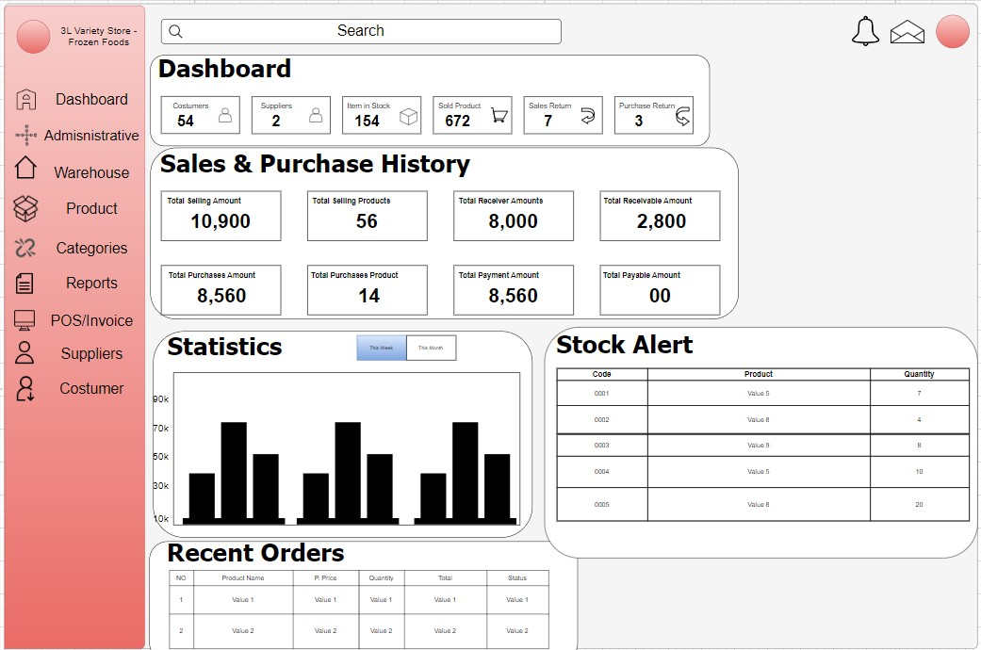

Figure 2: Prototype Dashboard  
  
Dashboard - This is where they can see the process of sales, purchase to statistics, stock alert and up to recent orders. We made it compact for our client to not be looking around the system for updates.

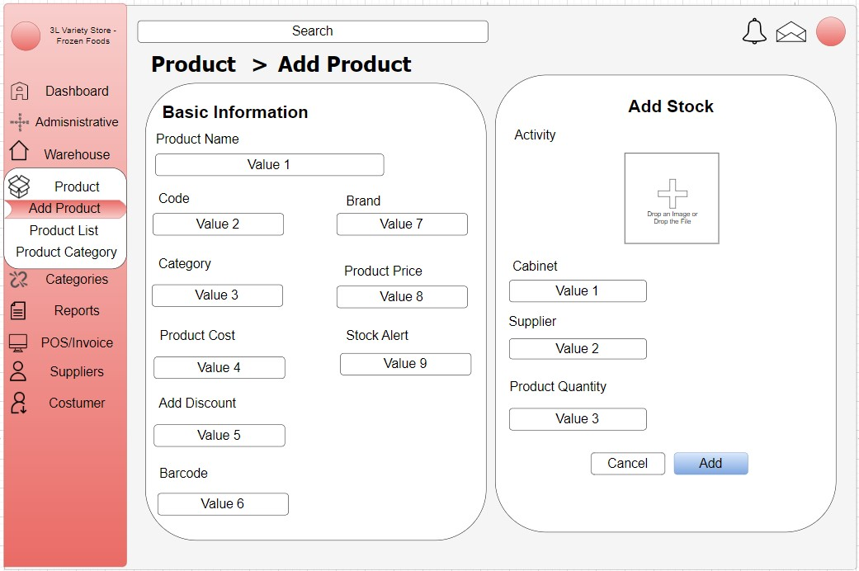

Figure 3: Prototype Sign up

Add products are where they can input all product contents and all the needed details to be organized and add the stock into the system inventory.

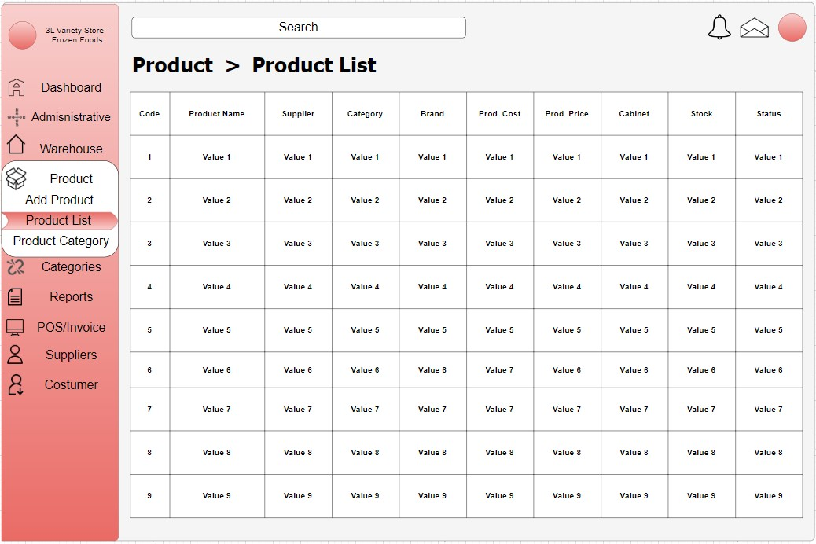

Figure 4: Prototype Homepage

Product List consists of every bit of product that is handled and know every detail of it.

The home page consists of a header and body. The header has the logo of the business, about us, the shop and contact us while it also has a search tab and Order now button. It also consists of 2 features photos of what the business is selling and a brief context about the business. They can also click "Shop now" to proceed with buying.

It consists of a different variety of the products that the business is selling. It add or minus depending on how many products are needed.

It consists of a different variety of the products that the business is selling. It add or minus depending on how many products are needed.

It contains the final order and the total price of the products. They can pay in Gcash and pick it up or they can pay in the store and pick it up

## 5.7 Release Plan

**Target Group:** 3 – L Variety Store and Frozen Goods

**Goal:** Create an inventory management system for Lorena's local food store, as well as a mobile/web app to handle inquiries from customers.

**Needs:** A platform that simplifies inventory management, supplier interaction, and customer contacts, supported by strong technical support and dependable infrastructure.  
**Key Features:** Real-Time Inventory Tracking, Automated Reordering, User Login, Customer Query Interface (Mobile/Web App), Supplier Management, Analytics, and Database Management

**Release 1:**

1. Research Paper
2. Pitch Video
3. PowerPoint Presentation
4. Wireframe

**Release 2:**

1. Database Modelling
2. Web application development
3. User login
4. Inventory Management
5. Beta Testing

**Release 3:**

1. Customer Mobile/Web app
2. Predictive Analysis
3. Report analysis
4. Bug fixes
5. Platform integration (Phone, Tablet UI)

Our Product Backlog could change in the future as our developers feel like there are parts of the system that are missing in future releases.

# References:

[1] Create your online store today with Shopify. (n.d.). Shopify. https://www.shopify.com/ph/free-trial/3s?term=shopify&adid=566143386710&campaignid=15433369419&branded_enterprise=1&BOID=brand&utm_medium=cpc&utm_source=google&gad_source=1&gclid=CjwKCAjwnK60BhA9EiwAmpHZwzSkQnBvohIl-m6N5u_N9MRlrvjrnkz3zOBZsIn-iPtIY2PICagchxoCUOYQAvD_BwE&cmadid=516585705;cmadvertiserid=10730501;cmcampaignid=26990768;cmplacementid=324494758;cmcreativeid=163722649;cmsiteid=5500011

[2] Zoho Corporation Pvt Ltd. (n.d.). Online inventory management software | Zoho Inventory. https://www.zoho.com/inventory/

[3] foodpanda Philippines. (n.d.). Food & Grocery Delivery - Restaurants near me in the Philippines | foodpanda. Foodpanda Philippines. https://www.foodpanda.ph/

[4] Square (n.d.). Square. Retrieved July 7, 2024, from https://squareup.com/us/en

[5] About Amazon. (n.d.). US About Amazon. https://www.aboutamazon.com/?utm_source=gateway&utm_medium=footer

[6] About UNiQLO | UNIQLO. (n.d.). https://www.uniqlo.com/uk/en/info/about.html

[7] About us | Sephora. (n.d.). Sephora. https://www.sephora.com/beauty/about-us

[8] de Vries, J. (2014). The influence of power and interest on designing inventory management systems. International Journal of Production Economics, 143(2), 233-241.

[9] Civelek, I. (2017). Sustainability in inventory management. In Intelligence, Sustainability, and Strategic Issues in Management (pp. 43-56). Routledge.  
  
[10] Lee, Chee Sun, Cheang, Yeng Sharon et al. (March 2022). Predictive Analytics in Business Analytics: Decision Tree. <https://www.proquest.com/openview/3453584715adbe9094f8bd061f67f64d/1?pq-origsite=gscholar&cbl=25336>[11] [**Özge Albayrak Ünal,**](https://www.researchgate.net/profile/Oezge-Albayrak-Uenal?_tp=eyJjb250ZXh0Ijp7ImZpcnN0UGFnZSI6InNpZ251cCIsInBhZ2UiOiJwdWJsaWNhdGlvbiJ9fQ) [**Burak Erkayman,**](https://www.researchgate.net/profile/Burak-Erkayman?_tp=eyJjb250ZXh0Ijp7ImZpcnN0UGFnZSI6InNpZ251cCIsInBhZ2UiOiJwdWJsaWNhdGlvbiJ9fQ) [**Bilal Usanmaz.**](https://www.researchgate.net/profile/Bilal-Usanmaz?_tp=eyJjb250ZXh0Ijp7ImZpcnN0UGFnZSI6InNpZ251cCIsInBhZ2UiOiJwdWJsaWNhdGlvbiJ9fQ) (2023, February). Applications of Artificial Intelligence in Inventory Management: A Systematic Review of the Literature. <https://www.researchgate.net/publication/368345493_Applications_of_Artificial_Intelligence_in_Inventory_Management_A_Systematic_Review_of_the_Literature>

[12] [Chuning Deng](https://onlinelibrary.wiley.com/authored-by/Deng/Chuning), [Yongji Liu.](https://onlinelibrary.wiley.com/authored-by/Liu/Yongji) (2021, October 11). A Deep Learning-Based Inventory Management and Demand Prediction Optimization Method for Anomaly Detection. <https://onlinelibrary.wiley.com/doi/10.1155/2021/9969357>

# Appendices

## Appendix A: Project Vision

To transform inventory management at Lorena's local food store by deploying an innovative system that easily includes real-time inventory tracking, automatic reordering, and user-friendly consumer inquiry interfaces via mobile and web-based apps. This system will provide effective supplier management, analytics, and reliable database administration, resulting in optimal stock levels, increased customer satisfaction, and efficient operations.

## Appendix B: Schedule/Release Plan

|  |  |  |
| --- | --- | --- |
| MNTSDEV | MYSADD1 | MCSPROJ |
| * Research Paper * Pitch Video * PowerPoint Presentation * Wireframe/Prototype | * Database Modelling * Web Application Development and mobile application * User login * Interface development * Beta Testing | * Integrating A.I Analytics * Report analysis * Bug fixes * Platform integration |

Table 5 Release Plan

## Appendix C: Product Roadmap

|  |  |  |
| --- | --- | --- |
| Q1 | Q2 | Q3 |
| Milestone 1:  * Approval process * Documentation * Pitch Video * Wireframe/Prototype | Milestone 2:  * UI/UX Design * Database Modeling * Design Documentation * Development  Milestone 3:  * Revision of Paper * Prototype Testing * Bug Fixes | Milestone 4:  * Deployment of Project * Finalizing Software * Implementation * Submission of Design Documentation |

Table 6: Poduct Roadmap

## Appendix D: Teams Meetings

|  |  |  |  |
| --- | --- | --- | --- |
| DATE | PARTICIPANT/S | AGENDA | RESOLUTION |
|  |  |  |  |
| JUNE 25, 2024 | * Anamika Nepomuceno * Timothy Louise Perez * Ichiro Emmanuel Pongos * Rainier Lopez * Ms. Maria | * Discussing the flow of their business | * Understand the clients’ hardships with their current system |
| JUNE 25, 2024 | * Anamika Nepomuceno * Timothy Louise Perez * Ichiro Emmanuel Pongos * Rainier Lopez | * Documentation | * Finishing the lean canvas and making a draft of the entire documentation with the help of everyone |
| JUNE 26, 2024 | * Anamika Nepomuceno * Timothy Louise Perez * Ichiro Emmanuel Pongos * Rainier Lopez | * Documentation * Prototype * Discussion about the Project | * Finalizing every part of the document necessary for the finals requirement |
| JULY 1, 2024 | * Anamika Nepomuceno * Timothy Louise Perez * Ichiro Emmanuel Pongos * Rainier Lopez | * Documentation * Discussing about the remaining parts of the Documentation | * Finalizing the remaining parts of the Documentation |
| JULY 4, 2024 | * Anamika Nepomuceno * Timothy Louise Perez * Ichiro Emmanuel Pongos * Rainier Lopez * Mr. Manuel L. Calimlim Jr. | * Consultation for the whole Documentation | * Revising the parts that needs to be revised |
| JULY 7, 2024 | * Anamika Nepomuceno * Timothy Louise Perez * Ichiro Emmanuel Pongos * Rainier Lopez * Ms. Maria | * Discussing the whole documentation with the client | * Finalizing the whole documentation |
| JULY 8, 2024 | * Anamika Nepomuceno * Timothy Louise Perez * Ichiro Emmanuel Pongos * Rainier Lopez * Sir Jayvee M. Cabardo | * Last Consultation for the whole documentation | * Finalizing and revising the parts that needs to be revised * Finalizing the prototype |

Table 7: Minutes Of The Meeting

**Screenshots of the Meetings:**   
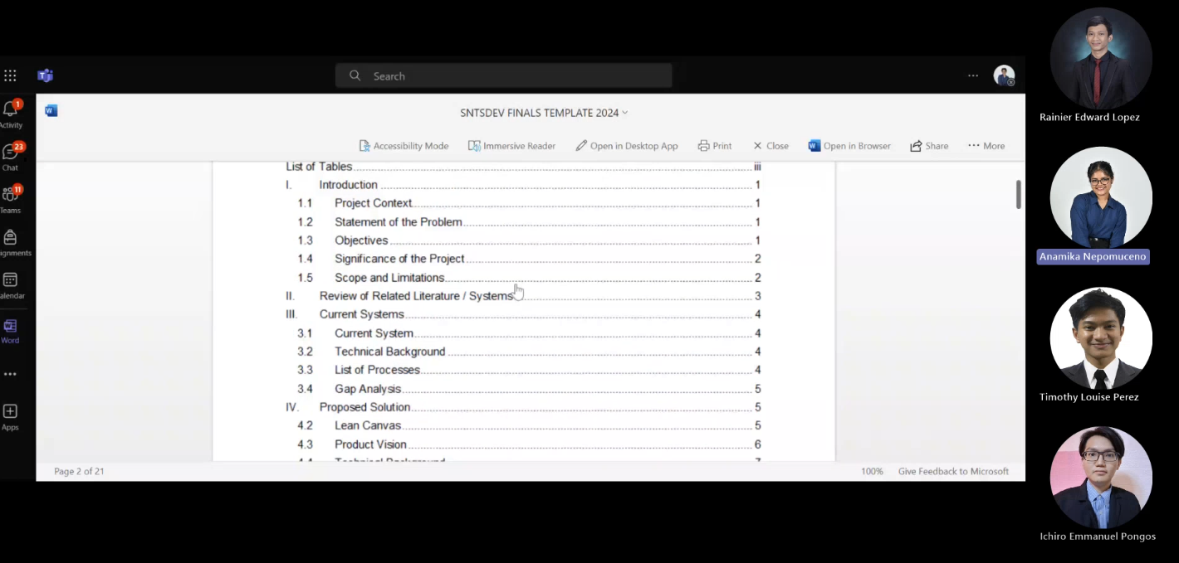

Figure 5: Team Meeting (1):



Figure 6: Meeting with Client

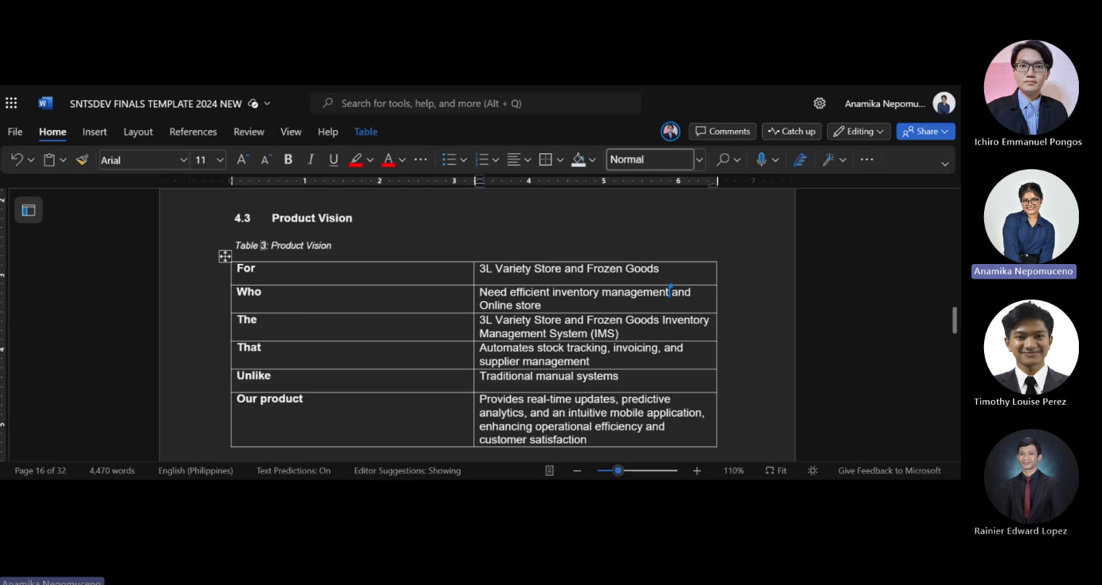  
July 1, 2024

Figure 7: Team Meeting

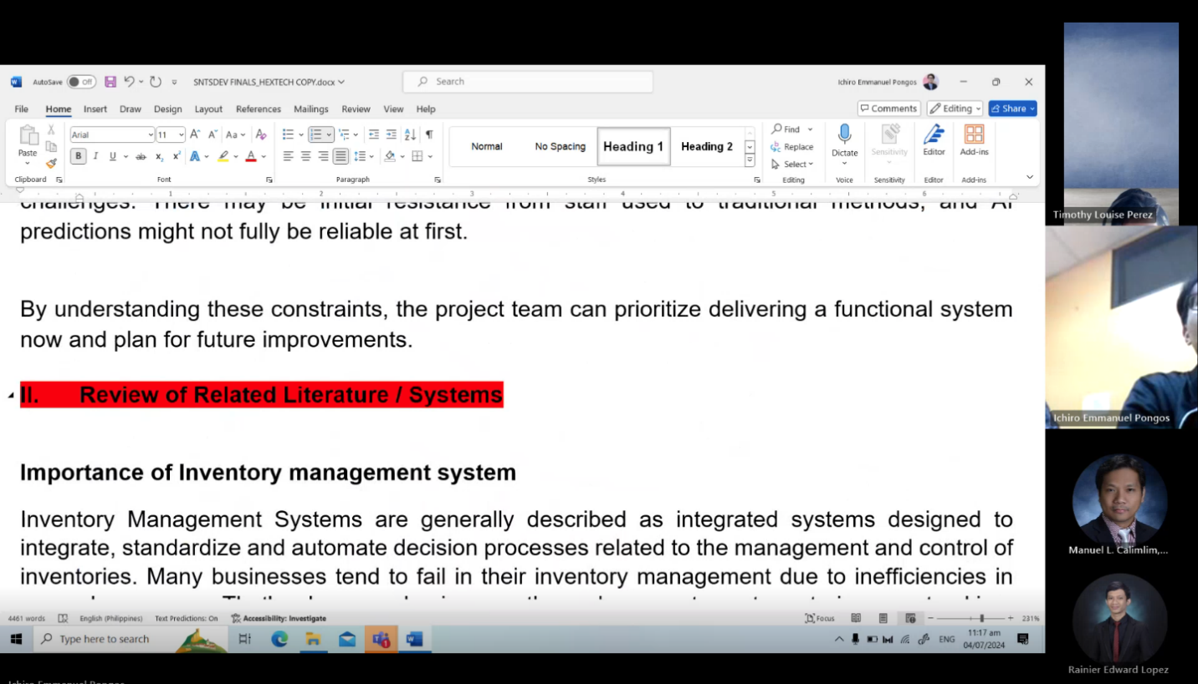  
July 4, 2024

Figure 8: Consultation Meeting

July 7, 2024

Figure 9: Meeting with Client

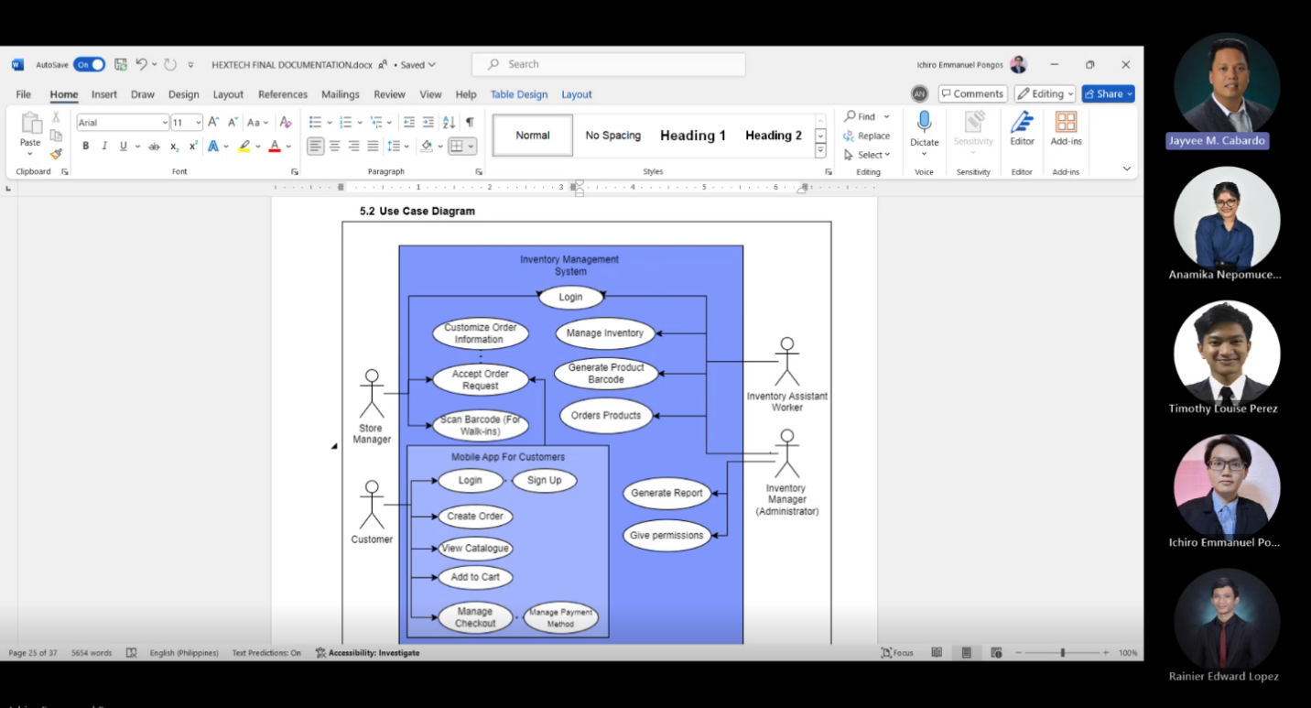

July 8, 2024

Figure 9: Consultation Meeting